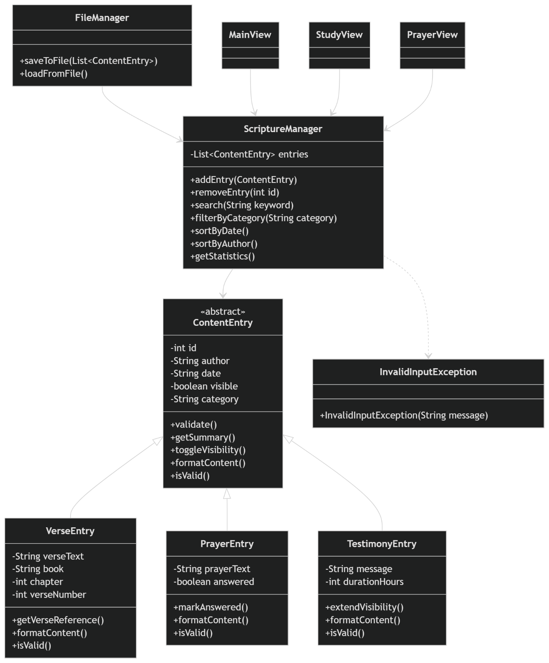

Scripture Space:

File Manager:

saveToFile() -> saves all entries
loadFromFile() -> loads data at startup
Purpose: Ensures data is stored permanently

ContentEntry(Abstract Superclass)
This is the base class for all content types in the application.

Attributes:
Id -> unique identifier for each entry
author → creator of the entry
date → creation date
visible → whether the entry is visible (e.g., 24h testimony rule)
category → type of content (Prayer, Verse, Discussion, etc.)

Methods:
validate() → checks if the data is valid
getSummary() → returns a short summary of the content
toggleVisibility() → switches visibility on/off
formatContent() (abstract) → defines how content is displayed
isValid() (abstract) → validation logic specific to each subclass

Why abstract?
Because each content type has different rules and formatting.

VerseEntry (Subclass)

Extra Attributes:
verseText → the actual Bible verse
book → book of the Bible
chapter → chapter number
verseNumber → verse number

Methods:
getVerseReference() → e.g. “John 3:16”
formatContent() → formatted display of the verse
isValid() → checks if the verse data is correc

PrayerEntry(Subclass)
Represents a prayer shared by a user.
Extra Attributes:
prayerText → content of the prayer
answered → whether the prayer has been answered
Methods:
markAnswered() → marks prayer as answered
formatContent() → formats prayer display
isValid() → validates prayer input

TestimonyEntry(Subclass)
Represents a testimony or personal experience with God.
Extra Attributes:
message → testimony content
durationHours → how long it stays visible (e.g., 24 hours)
Methods:
extendVisibility() → extends visibility time
formatContent() → formats testimony display
isValid() → validates content

ScriptureManager(Service/Controller Class)
This ist he core logic class of the application.
Purpose:
It manages all entries and contains the business logic.

Functions:
addEntry() → adds a new entry
removeEntry() → deletes an entry
search() → searches entries by keyword
filterByCategory() → filters content
sortByDate() / sortByAuthor() → sorting functionality
getStatistics() → computes analytics (e.g. number of prayers)

Important:
All business logic is handled here, not in the UI

InvalidInputException
A custom exception class.

Purpose:
Handels invalid user input safely
Examples:
empty prayer text
invalid verse reference
missing category
Benefit:
Prevents crashes and ensures clean error handling

FileManager
Responsible for date persistence (saving and loading).

Funtions:
saveToFile() → saves all entries
loadFromFile() → loads data at startup
Purpose:
Ensures data is stored permanently

Vaadin Views (GUI Layer)
MainView:
Home screen
Navigation between pages
StudyView:
Bibel verses
Study discussions
Filters and search
PrayerView:
Prayer management
Answered/pending status
Add new prayers

Relationships

Inheritance:
ContentEntry is the base class
VerseEntry, PrayerEntry, TestimonyEntry inherit from it
This enables polymorphism, meaning all entries can be handled uniformly.

Service Layer:
ScriptureManager manages all ContentEntry objects
→ works with all subclasses through polymorphism

UI Layer:
Vaadin views communicate only with ScriptureManager
→ no business logic inside the GUI

Exception Handling:
ScriptureManager throws InvalidInputException when needed
→ ensures safe validation

Short Summary (for presentation)
The system follows a layered architecture separating model, business logic, file handling, and GUI. This ensures clean design, scalability, and proper object-oriented programming principles such as inheritance, polymorphism, and encapsulation.

